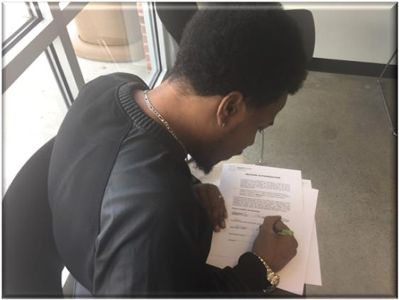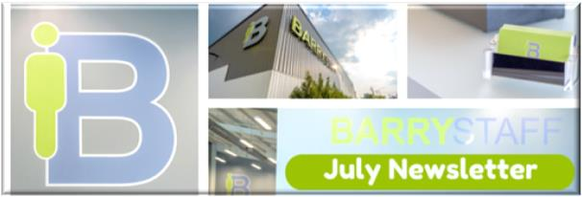**BARRYSTAFF Interviews Dozens at Job Fair**

It was a first for the newly opened Barrystaff office in Springfield. The decision was made to hold a job fair on June 8.

There were several unknowns.

Did people know about the new office? If not, were they willing to find it?

Luckily, there was nothing to worry about.

The job fair was more successful than BarryStaff ever imagined. More than 50 percent of the applicants interviewed were qualified to fill oft-needed positions at Clark County area companies.

Within the next week, BarryStaff employees in Springfield had three people working. Five more were awaiting interviews with local companies.

One applicant, in fact, was placed the day he interviewed at the job fair.

“I have two after-work functions that I’m hoping will benefit,” said BarryStaff’s Pam Bartee. “I also took all the applications to a couple new customers.”

One man, who said he saw advertisements for the job fair in the newspaper and on TV, said people are willing to do anything to work.

“I think (job fairs) are a good thing,” he said. “There are a lot of people who need jobs and there are a lot of good workers who aren’t working.”

Roughly 25 people interviewed over the span of a few hours.

BarryStaff is currently in the midst of planning another job fair, this time at the company’s headquarters in Dayton. Details will be released as plans are finalized.

**BarryStaff Celebrates One Year in New Facility**

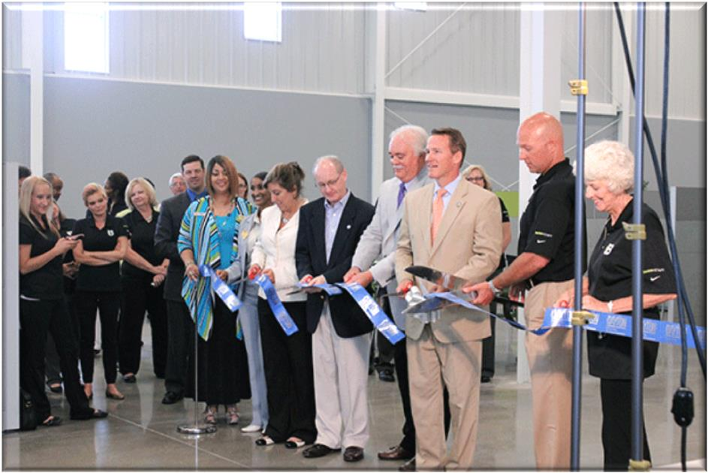Call it a milestone in BarryStaff’s commitment to the downtown Dayton area.

The company’s brand new 13,000 square foot facility opened June 1, 2015 on Webster Street. One year later, BarryStaff continues to work with local companies to supply industrial, clerical and permanent job placements.

BarryStaff is also the only business in Dayton licensed to screen travelers for the TSA Pre-Check program.

Ground was broken on the new facility in December 2014. The 32-year-old business is proud of its downtown Dayton heritage, having operated from three other downtown locations since 1982.

“Our new facility has allowed us the space to better serve our applicants and expand our services to our clients,” said President and CEO Doug Barry.

The Pam and Warren Barry Community Room also opened in 2015. To date, more than 50 businesses and organizations have requested to utilize the room for off-site retreats. With enough space for 80 people, white boards and an exquisite view of downtown Dayton, BarryStaff is proud to serve business professionals on its home turf.

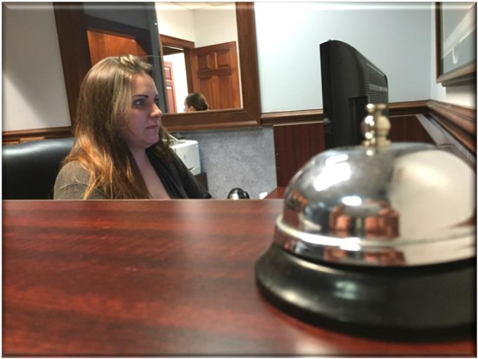**Employee Spotlight: Kaytee Ryan of Active Electric**

In 2015, Kaytee Ryan moved from Denver to Dayton. She needed work, but application after application seemed to fall on deaf ears.

Her online pursuit led her to BarryStaff, and the staffing agency became one of her first stops after she unpacked in Dayton.

“I got a good vibe from everyone,” she recalled.

Ryan now works as an administrative assistant with Active Electric in Moraine. She was full-time after 90 days and she’s now been with the company over a year.

“I’m definitely staying here,” she said. “This will be my second home for a while.”

At a time when so many job seekers struggle to stand out above hordes of other applicants, Ryan said she felt relieved that BarryStaff offered to send a video resume to clients. The videos are kept short – 60 seconds. And the appearance is sleek.

“It’s good to put a face to the person,” Ryan said. “I think it sped up the hiring process.”

After months of job seeking, Ryan said relief was suddenly in sight.

“With BarryStaff, everything seemed seamless,” she said. “It was easy. Not complicated.”

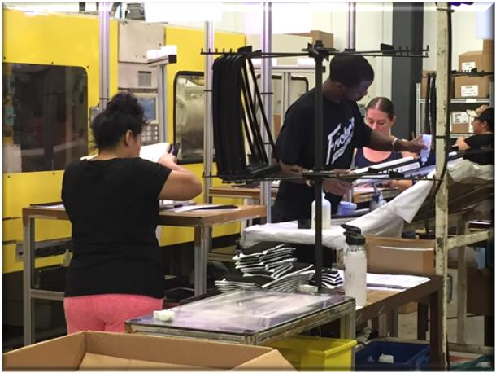**Client Spotlight: Steve Jones of ASPM**

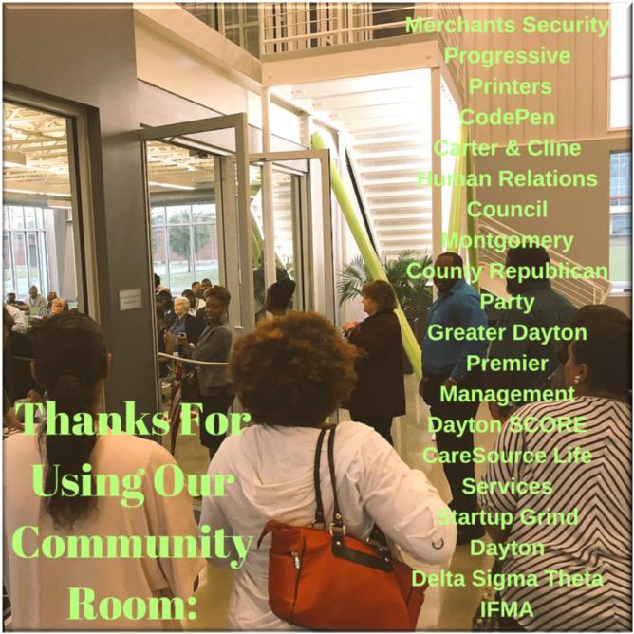

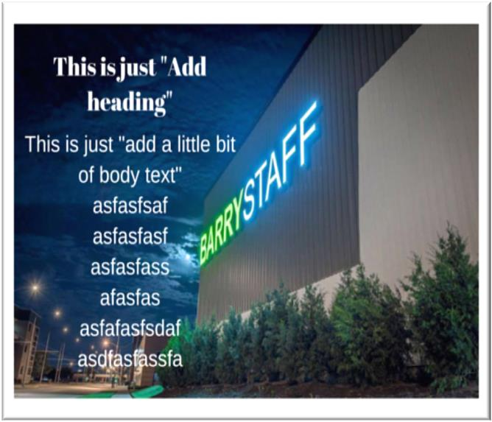

Random Business Fact: *Wal-Mart averages a profit of $1.8 million every*[*hour*](http://money.msn.com/investing/post--14-wal-mart-facts-that-will-blow-your-mind?ICID=TheStreet)*.*